CS 3350 Assignment 6 Due: Sunday, Dec 1, 11:59 p.m.

Q1: Check if a binary tree is a min-heap or not (10 points)
Goal(s): Practice with the heap data structure and preorder traversal of trees

What you are given:
- The file Q1-isHeap.cpp

What you should do:
Given a binary tree, check if it is a min-heap or not. In other words, the binary tree must be a complete binary tree where each node has a higher value than its parent’s value. For example, the following binary tree is a min-heap:
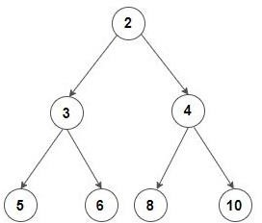

On the other hand, the following binary tree is not a min-heap:
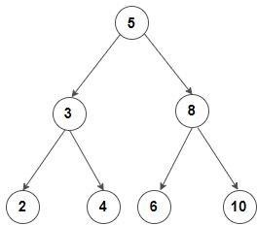

Complete the file Q1-isHeap.cpp. Please note that you must provide a recursive
implementation.

Q2: Find k’th largest element in an array (10 points)
Goal(s): Practice with the min-heap data structure.

What you are given:
- The file Q2-k-largest.cpp

What you should do:
Given an integer array, find k’th largest element in the array where k is a positive integer less than or equal to the length of array. For example:
Input:

arr = [7, 4, 6, 3, 9, 1]
k = 2

Output:

The 2nd largest array element is 7

Complete the file Q2-k-largest.cpp. Please note that you must provide an implementation using the min-heap data structure. You may create auxiliary functions as needed and use the heapify() function as presented in the class.

What to submit
- Completed Q1-isHeap.cpp
- Completed Q2-k-largest.cpp

Grading Rubric
_______ (4) proper documentation/comments where appropriate.
______ (8) implementation of Q1.
_______ (8) implementation of Q2

